Moving/sharing data files
RD Manager, PCMx Manager

You can send the entire data file to another user and they can load that file in another copy of RD Manager/PCMx Manager and work with the data just the same as the original user.

In your Windows Documents directory

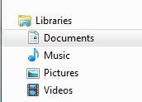

you will see the “Radiodetection Ltd” directory [select it].

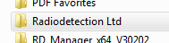

Then selecting either “RD Manager/PCMx Manager ” You will see the following directories:

RD Manager PCMx Manager
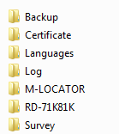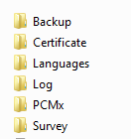

RD Manager

For survey data
go to the “Survey” directory and copy and send the desired .bin file

Example: (This one is for a PDLG locator with serial number #172)

Note: this will need to go into the same directory on the computer of the person you are sending it to!

For the usage logging
Go to the “Log” directory and copy the data files, you will need the .bin & the .idx files

Example:
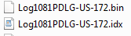

PCMx Manager

For the Survey data:
For survey data go to the “Survey” directory and copy and send the desired .bin file

Example:

For the PCMx ACCA data:
taken with the Magnetometer installed go to “Log directory” you will see:

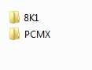
“PCMX” is where you need to be!
In there you will see two files that end with the unit serial number and .bin & .idx

Example: (this unit was Serial number #89)
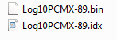

Copy and send these two files to the new user.

Note: this will need to go into the same directory on the computer of the person you are sending it to!

Usage logging
Go to the “8K1” directory and copy the data files, you will need the .bin & the .idx files
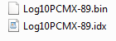

If you need assistance with this process contact Radiodeteciton technical service.

