**Moving/sharing data files**

**RD Manager, PCMx Manager**

You can send the entire data file to another user and they can load that file in another copy of RD Manager/PCMx Manager and work with the data just the same as the original user.

In your Windows Documents directory

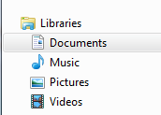

you will see the “Radiodetection Ltd” directory [select it].

cid:image013.png@01D44108.5A2D0270

Then selecting either  “RD Manager/PCMx Manager ” You will see the following directories:

RD Manager PCMx Manager

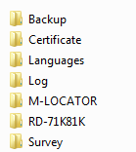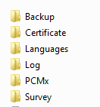

**RD Manager**

For survey data

go to the “Survey” directory and copy and send the desired .bin file

*Example:* (This one is for a PDLG locator with serial number #172)



Note: this will need to go into the same directory on the computer of the person you are sending it to!

For the usage logging

Go to the “Log” directory and copy the data files, you will need the .bin & the .idx files

*Example:*



**PCMx Manager**

For the Survey data:

For survey data go to the “Survey” directory and copy and send the desired .bin file

*Example:*



For the PCMx ACCA data:

taken with the Magnetometer installed go to  “Log directory” you will see:

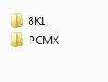

“PCMX” is where you need to be!

 In there you will see two files that end with the unit serial number and   .bin & .idx

*Example:* (this unit was Serial number #89)

cid:image015.png@01D44108.5A2D0270

Copy and send these two files to the new user.

Note: this will need to go into the same directory on the computer of the person you are sending it to!

Usage logging

Go to the “8K1” directory and copy the data files, you will need the .bin & the .idx files



If you need assistance with this process contact Radiodeteciton technical service.